3.3 Assignment
Trent Jorgensen
ECPI University
SDC385
Instructor: Dr. Iyinbor
March 16, 2026
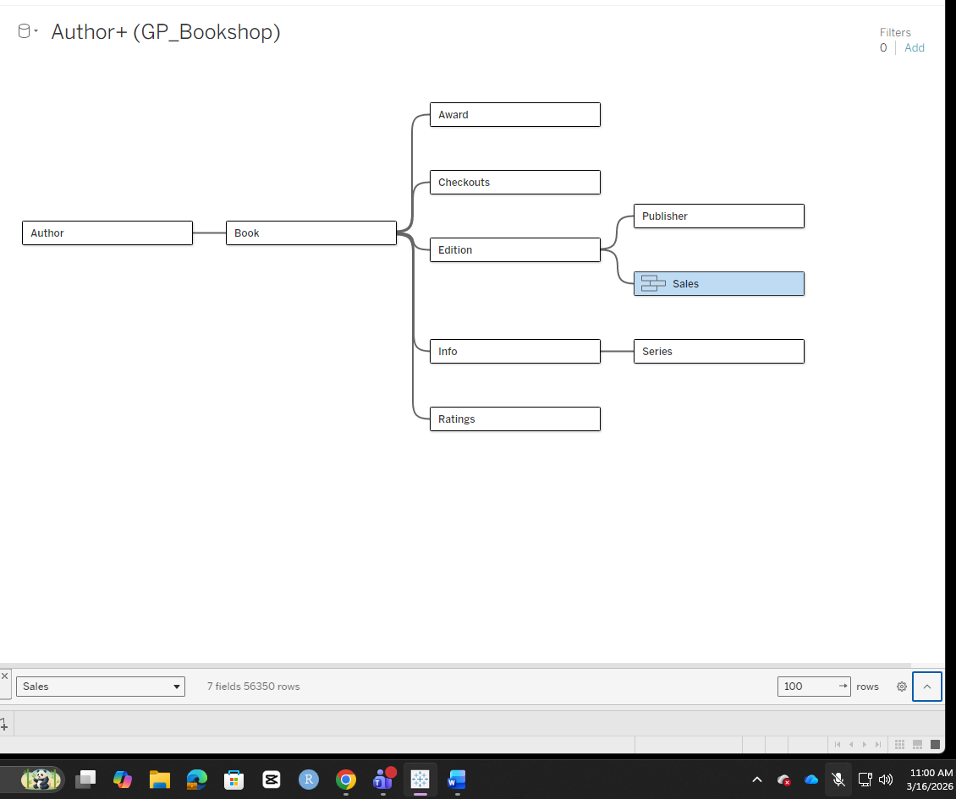
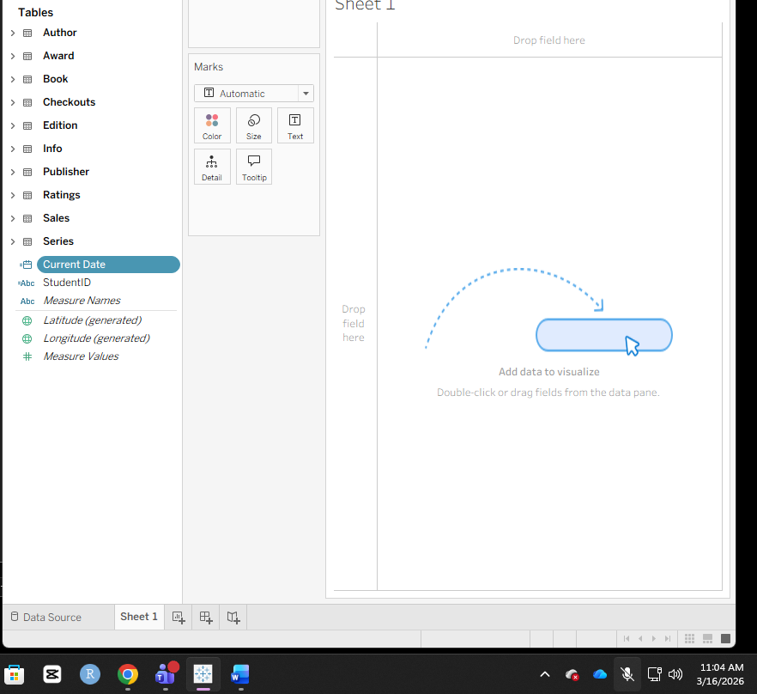
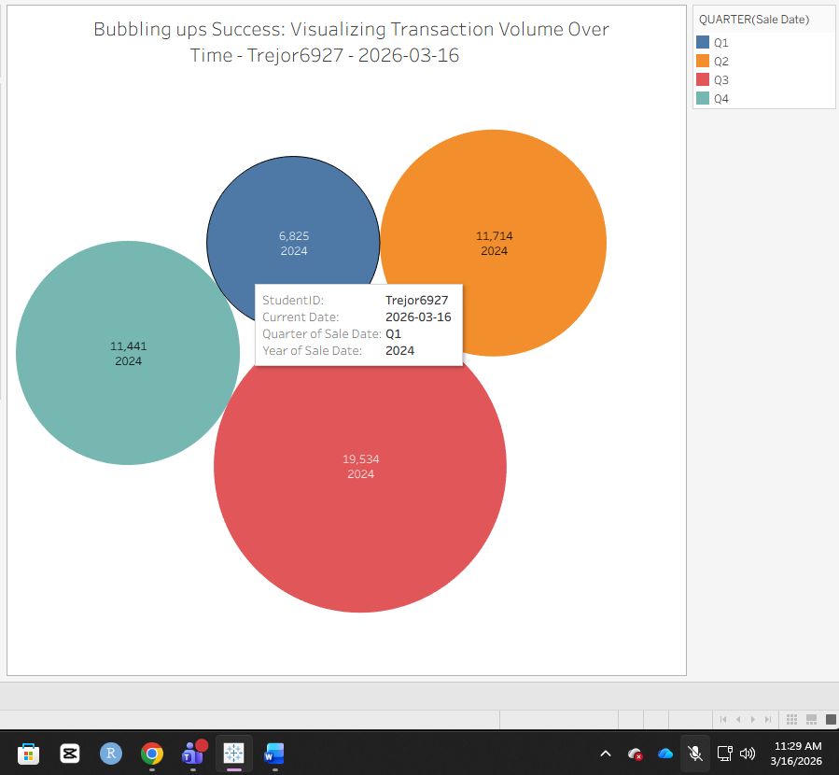
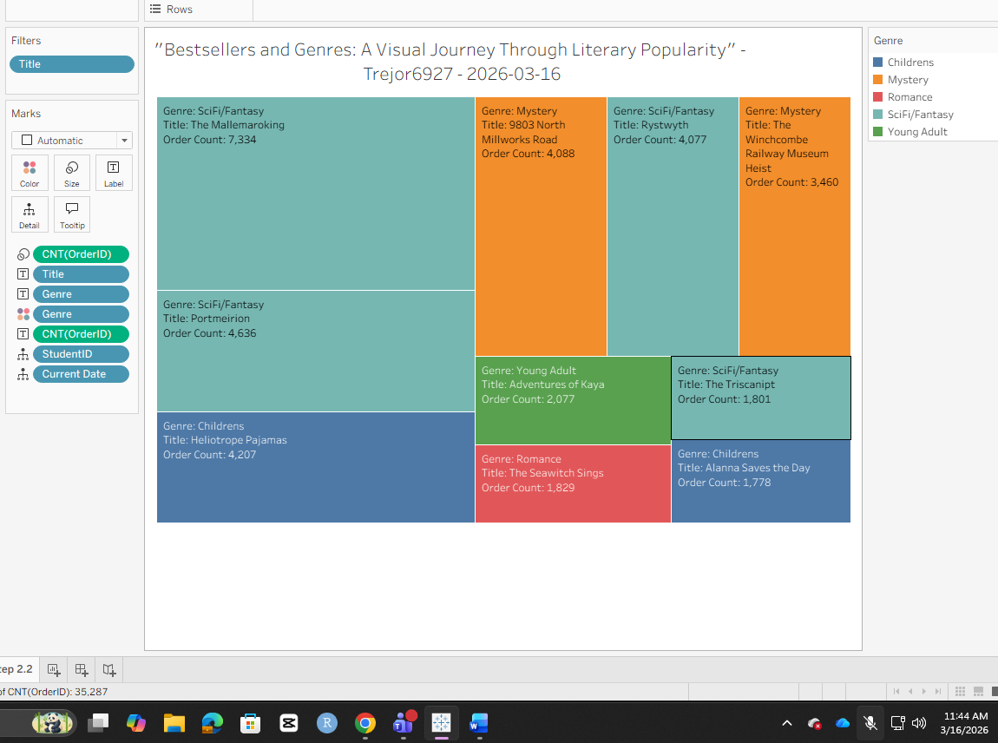
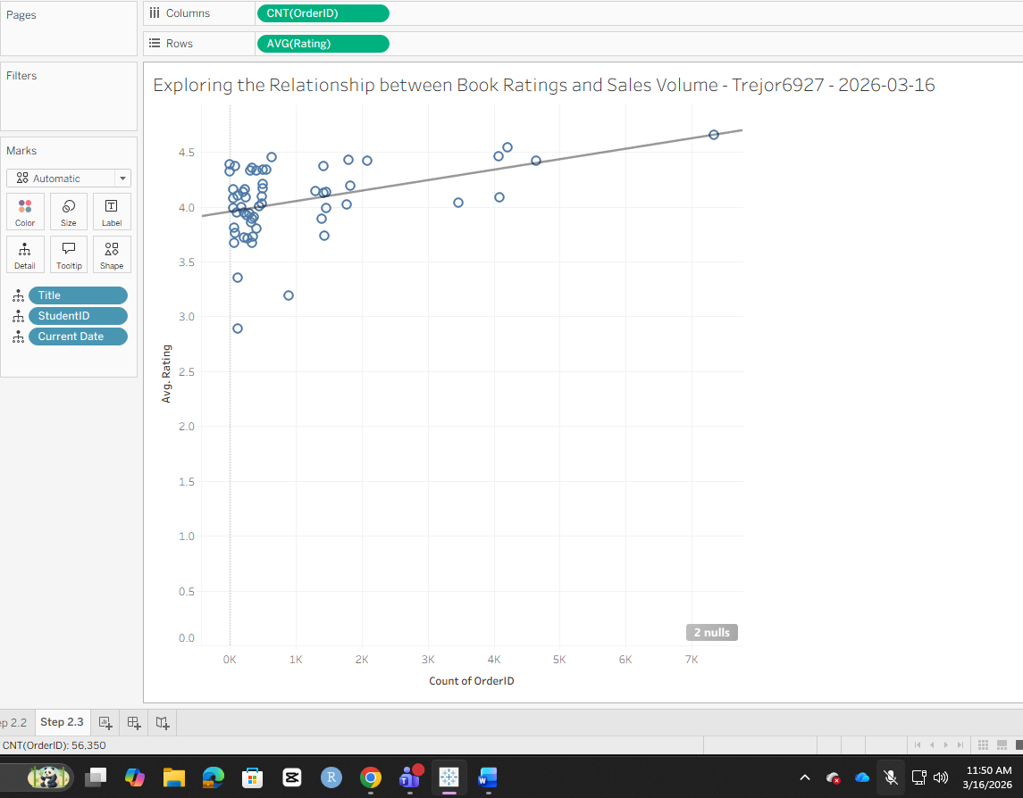
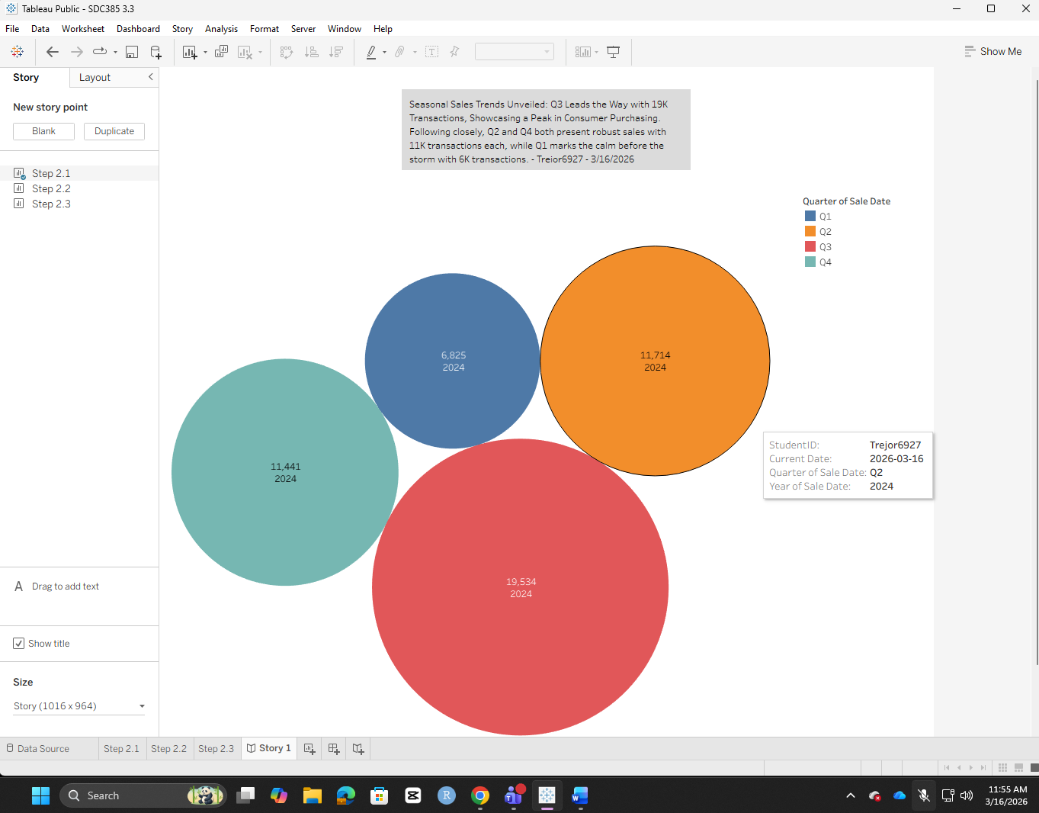
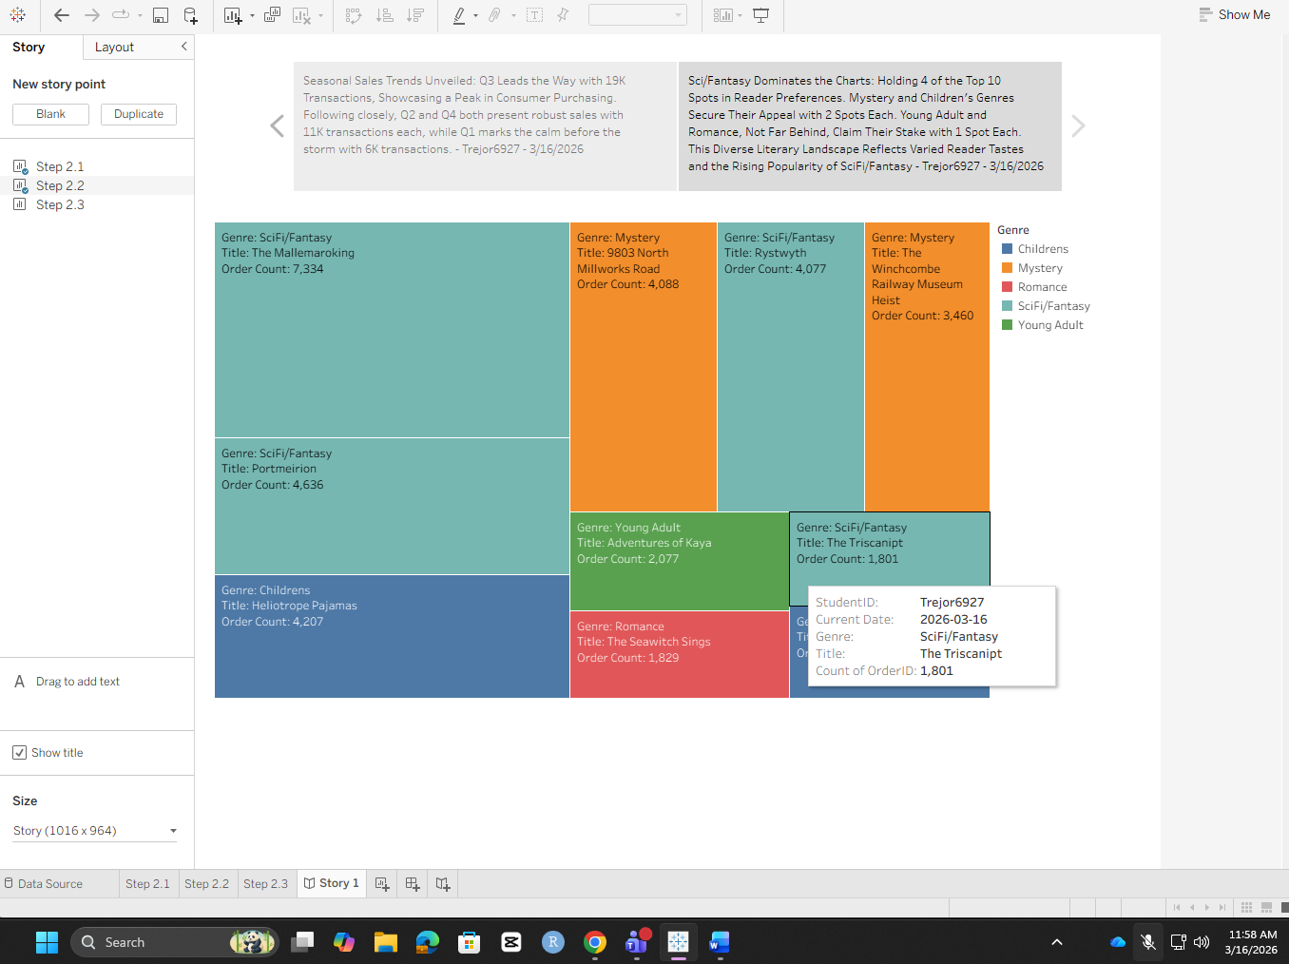
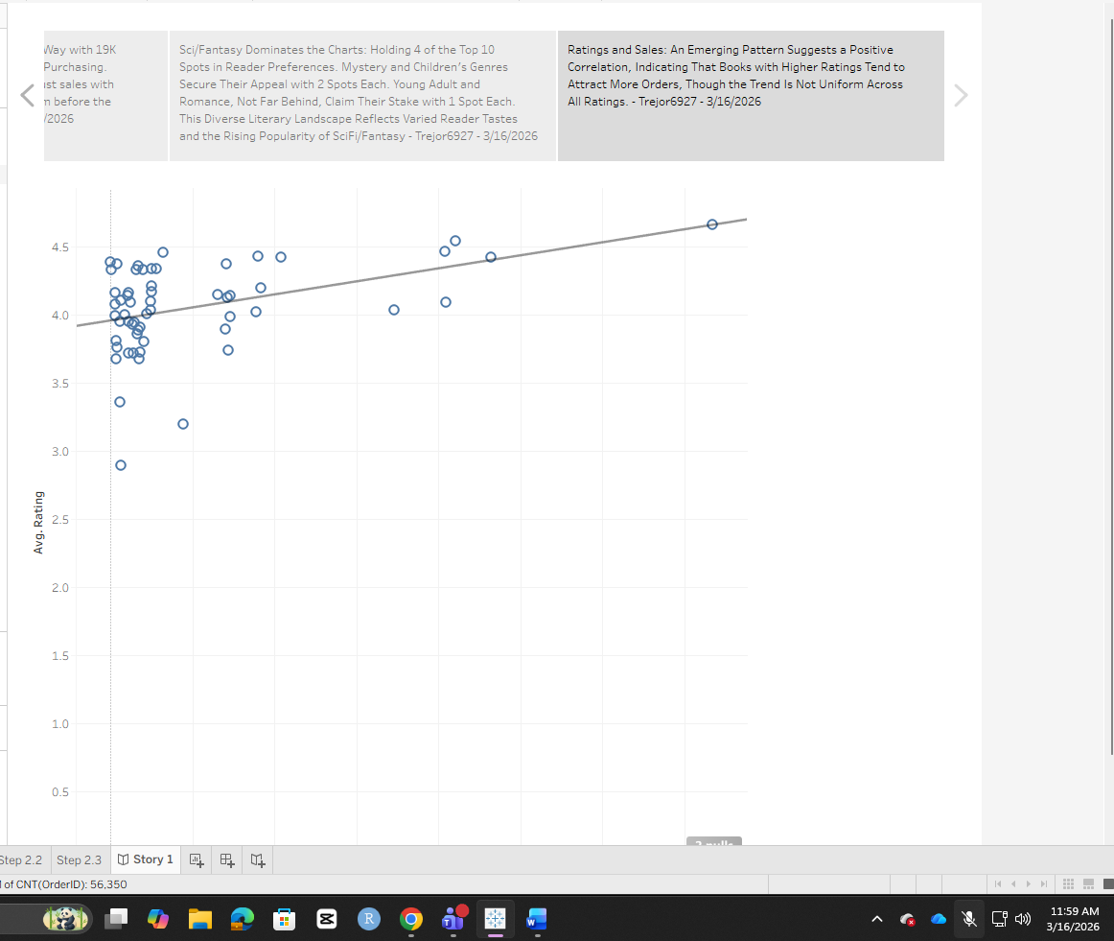
- What does the visualization created in Step 2.1, using packed bubbles to represent total order count, tell you about the relationship between quarters and sales volume?
The bubble chart shows that the first quarter is the lowest sales quarter, second quarter and fourth quarter are about the same and third quarter brings in the most amount of money. This could help a business decide when the best time to run a sale would be.

- How does the tree map visualization created in Step 2.2, which shows the count of orders by title and genre, assist in identifying trends in book sales?

It shows that the most popular genre is Scifi/Fantasy. Romance is the least popular. By looking at the data and trends, you can bet that the Scifi/Fantasy book called “The Triscanipt” will continue to grow. This book may have just been released recently.
- Based on the scatter plot created in Step 2.3, how does the relationship between book ratings and the number of orders illustrate the impact of customer satisfaction on sales?
This scatter plot is interesting. I say that because there is a good group of books that have a good rating but are not selling as much as they should. The majority of the books sold are less than two thousand. The Mallemaroking is clearly the best selling book with a high sales volume and good ratings. Looking at the data, I think that some of these books have fake ratings so that people go out and buy the books just like some of the Amazon reviews.

